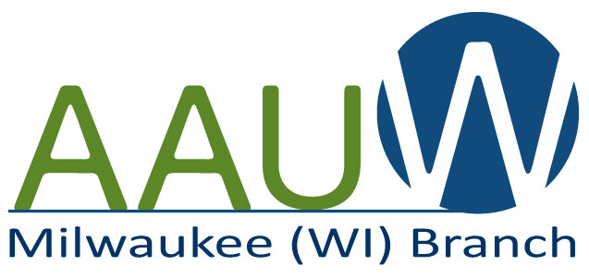
National Conference for College Women Student Leaders
2020 Scholarship Application Form

AAUW Milwaukee awards an annual scholarship for a Milwaukee college student to attend the AAUW National Conference for College Women Student Leaders (NCCWSL, or “nick-whistle”). The $1000 scholarship is to be used for registration, lodging, transportation, and meals for NCCWSL, May 27-May 30, 2020 at the University of Maryland, College Park.

CRITERIA:

- Female undergraduate student attending a Milwaukee-based college or university member of AAUW (Alverno College, Marquette University, MATC, MSOE, Mount Mary University, and UWM)
- Freshman, sophomore or junior level continuing student, who will be enrolled in Fall 2020
- Demonstrated history of student engagement on campus and/or in service to the community
- Ability to articulate how the student will benefit from attending NCCWSL
- If applicant qualifications are approximately equal, preference will be given to a student who is an AAUW student affiliate member

APPLICANT INFORMATION:

Name: Click or tap here to enter text.

Address: Click or tap here to enter text.

City, State and Zip: Click or tap here to enter text.

Phone: Click or tap here to enter text.

Email: Click or tap here to enter text.

College or University Name: Click or tap here to enter text.

Enrollment Status: ☐ Freshman ☐ Sophomore ☐ Junior

What are you studying at your college or university (i.e. major/minor), and why?
Click or tap here to enter text.

How have you been active on your campus and/or in the Milwaukee community?
Click or tap here to enter text.

How would attendance at the conference further your personal and/or professional goals?
(Conference information is available at www.nccwsl.org)
Click or tap here to enter text.

Which AAUW policy issue are you most passionate about and why?
(View AAUW’s policy issues at www.aauw.org/what-we-do/public-policy/aauw-issues)
Click or tap here to enter text.

☐ (Check box to affirm) By applying for AAUW Milwaukee’s 2020 NCCWSL Scholarship, I agree to:
- Provide a picture and write a short article regarding my NCCWSL experience, for the AAUW Milwaukee branch newsletter.
- Attend one of the AAUW Milwaukee branch meetings in fall 2020 to provide a short (10-minute) presentation on my NCCWSL experience.

APPLICATION DIRECTIONS & TIMELINE:

- February 14, 2020: Completed applications are due and should be submitted to aauw.milwaukee@gmail.com.
- March 2, 2020: Selection Committee will notify scholarship recipient.
- April 30, 2020 (NCCWSL registration deadline): Scholarship recipient must have registered for NCCWSL and scheduled her flight, in consultation with AAUW Milwaukee (aauw.milwaukee@gmail.com).
- May 27-May 30, 2020: Student attends NCCWSL conference.
- June 12, 2020: Student will submit receipts for any meal or transportation reimbursements to AAUW Milwaukee (aauw.milwaukee@gmail.com).
- Friday, June 26, 2020: Student will email AAUW Milwaukee (aauw.milwaukee@gmail.com) with a photo and short article about her experience at NCCWSL 2020 for the branch newsletter.
- Fall 2020: Student will attend an AAUW Milwaukee branch meeting to speak briefly (10 minutes) about her NCCWSL experience.

Application Deadline: February 14, 2020

